- TIC-TAC-TOE
AIM
To develop a simple Tic-Tac-Toe game using Python where two players can play by manually entering their positions.
OBJECTIVE
- To implement a two-player Tic-Tac-Toe game.
- To accept manual input from the players.
- To check for a winning combination.
- To identify a draw when all positions are filled.
ALGORITHM
- Start the program.
- Create an empty 3×3 game board.
- Display the board.
- Set Player X as the first player.
- Ask the player to enter a position from 1 to 9.
- Place the player's symbol in the selected position.
- Check whether the player has won.
- If won, display the winner and stop.
- If the board is full, display Draw and stop.
- Otherwise, change the player and repeat.
- Stop the program.

FLOWCHART:
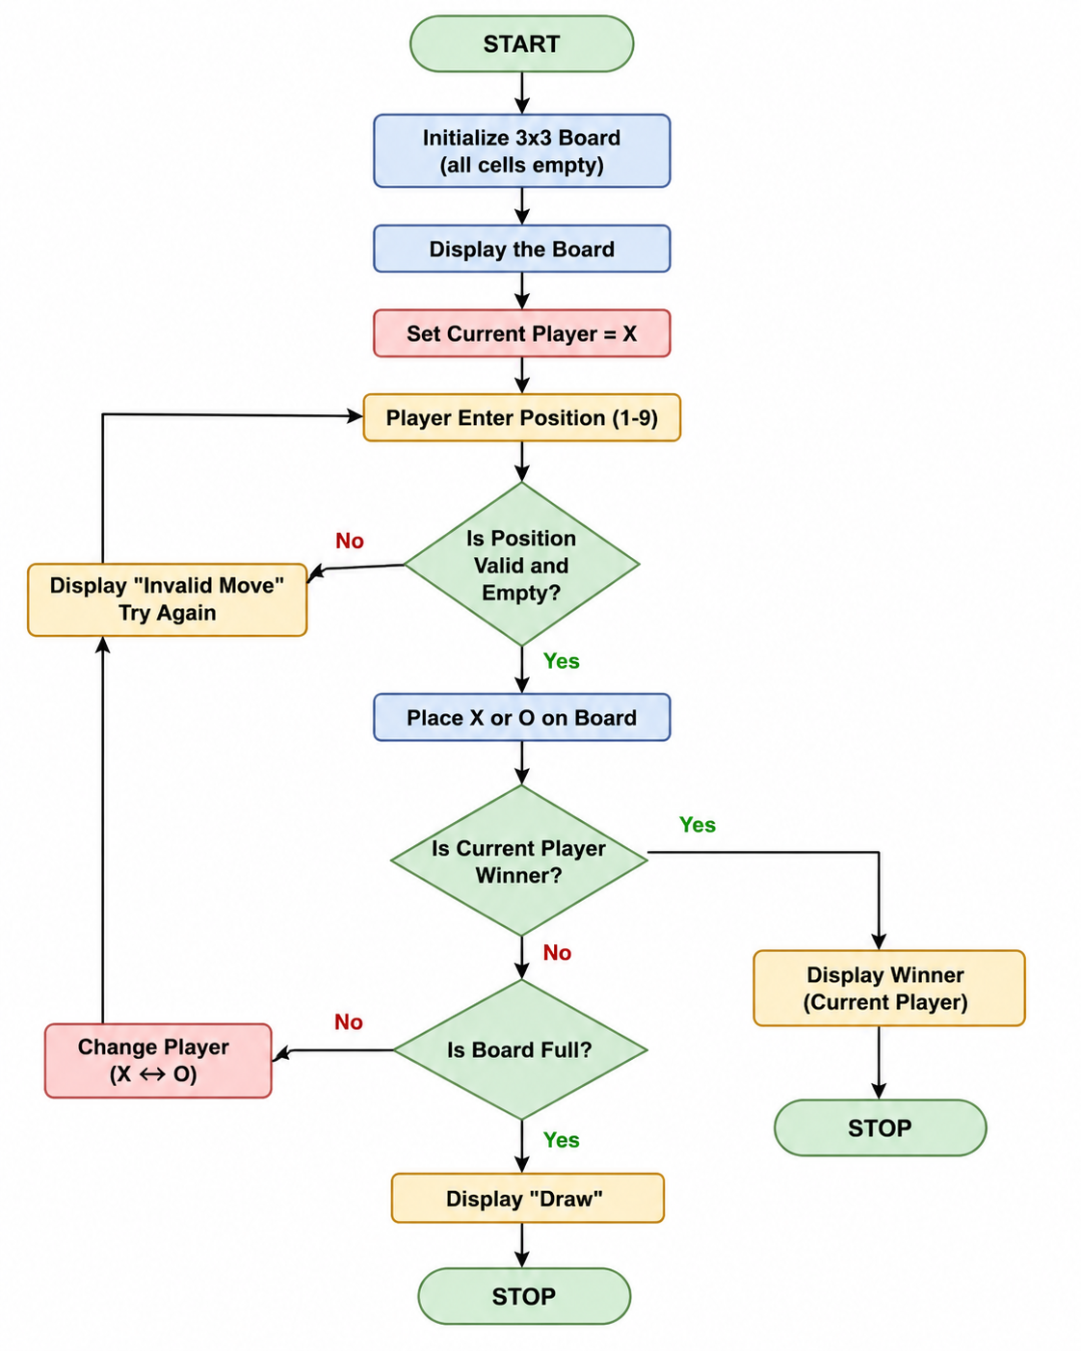
PYTHON CODE:
b = [" "]*9
def show():
print(b[0], "|", b[1], "|", b[2])
print("--+---+--")
print(b[3], "|", b[4], "|", b[5])
print("--+---+--")
print(b[6], "|", b[7], "|", b[8])
win = [(0,1,2),(3,4,5),(6,7,8),(0,3,6),(1,4,7),(2,5,8),(0,4,8),(2,4,6)]
for turn in range(9):
show()
p = "X" if turn % 2 == 0 else "O"
n = int(input(f"Player {p}, enter position (1-9): ")) - 1
if b[n] != " ":
print("Already taken!")
continue
b[n] = p
if any(b[a] == b[c] == b[d] == p for a,c,d in win):
show()
print("Player", p, "wins!")
break
else:
show()
print("Draw!")
OUTPUT:
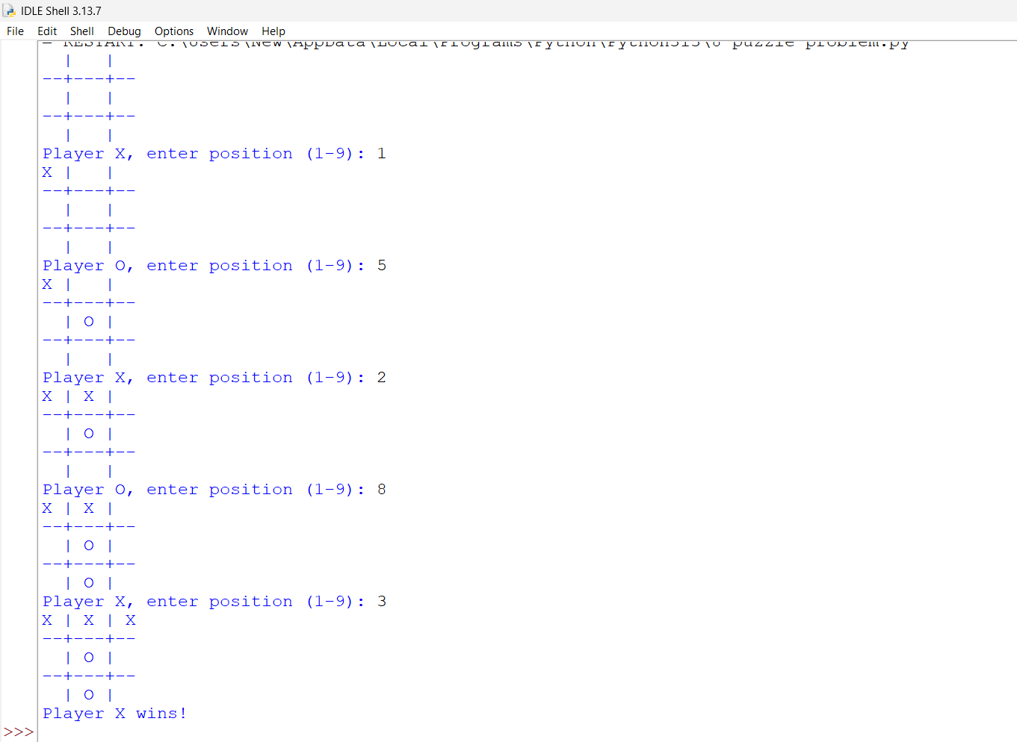
RESULT:
Thus, the Tic-Tac-Toe game was successfully implemented in Python using manual input. The program correctly identifies the winner or declares a draw.

